TPIZZA SALES SQL QUERIES

1. **KPI’S**
2. **PIZZA_SALES TABLE**

SELECT * FROM pizza_sales

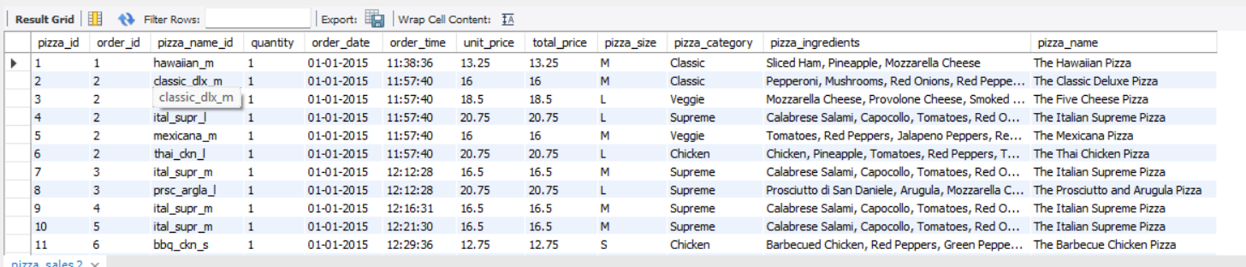

1. **TOTAL REVENUE**

SELECT ROUND(SUM(total_price) ,2) AS TOTAL_REVENUE

FROM pizza_sales;

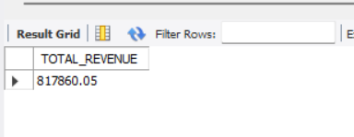

1. **AVERAGE ORDER VALUE**

SELECT ROUND(SUM(total_price)/COUNT(DISTINCT Order_id) ,2) AS AVERAGE_ORDER_VALUE

FROM pizza_sales;

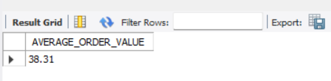

1. **TOTAL PIZZA SOLD**

SELECT SUM(QUANTITY) AS TOTAL_PIZZA_SOLD

FROM PIZZA_SALES;

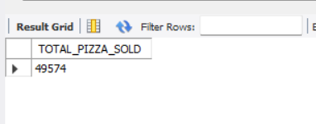

1. **TOTAL ORDERS**

SELECT COUNT(DISTINCT(Order_id)) AS TOTAL_OEDERS

FROM PIZZA_SALES;

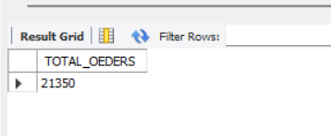

1. **AVERAGE PIZZAS PER ORDER**

SELECT ROUND(SUM(QUANTITY)/CAST(COUNT(DISTINCT Order_id)AS DECIMAL),2) AS TOTAL_PIZZAS_PER_ORDER

FROM PIZZA_SALES;

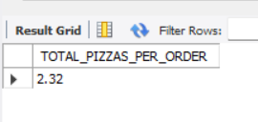

**B. DAILY TREND FOR ORDERS (FROM PostgreSQL)**

SELECT to_char(order_date,'Day') AS DAY, COUNT(DISTINCT order_id) AS Total_orders

FROM pizza_sales

GROUP BY to_char(order_date,'Day')

ORDER BY total_orders DESC

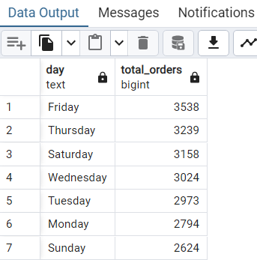

**c. HOURLY TREND FOR ORDERS**

SELECT EXTRACT(HOUR FROM order_time) AS ORDER_HOUR,

COUNT(DISTINCT order_id) as TOTAL_ORDERS FROM pizza_sales

GROUP BY EXTRACT(HOUR FROM order_time)

ORDER BY EXTRACT(HOUR FROM order_time);

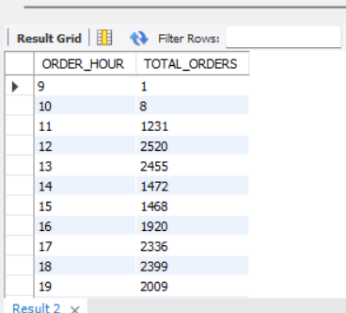

**D. PERCENTAGE OF SALES BY PIZZA CUTEGORY**

SELECT pizza_category,ROUND(SUM(total_price),2) AS TOTAL_SALES,

ROUND((SUM(total_price)/(SELECT SUM(total_price) FROM pizza_sales

))*100,2)AS PCT

FROM pizza_sales

GROUP BY pizza_category;

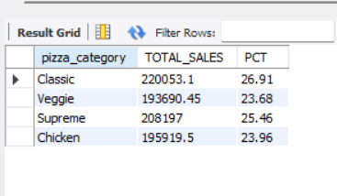

**E. PERCENTAGE OF SIZE BY PIZZA SIZE**

SELECT pizza_size, ROUND(SUM(total_price), 2) AS Total_sales,

ROUND((SUM(total_price) / (

SELECT SUM(total_price) FROM pizza_sales

WHERE QUARTER(STR_TO_DATE(order_date, '%Y-%m-%d')) = 4

)) * 100, 2) AS PCT

FROM pizza_sales

WHERE QUARTER(STR_TO_DATE(order_date, '%Y-%m-%d')) = 4

GROUP BY pizza_size

ORDER BY PCT DESC;

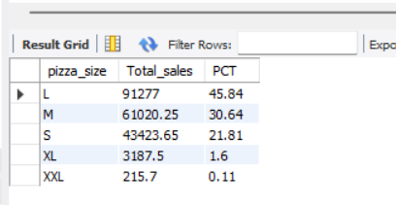

**F. TOTAL PIZZA SOLD BY PIZZA_CATEGORY**

SELECT pizza_category, SUM(quantity) AS NO_OF_PIZZA_SOLD

FROM pizza_sales

GROUP BY pizza_category;

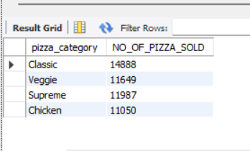

**G. TOP 5 BEST PIZZA SELLERS BY TOTAL PIZZA SOLD**

Top 5 best pizza sellers (for 1st month i.e. January)

SELECT pizza_name, SUM(quantity) AS TOTAL_PIZZA_SOLD

FROM pizza_sales

WHERE MONTH(STR_TO_DATE(order_date,'%d-%m-%y'))=1

GROUP BY pizza_name

ORDER BY TOTAL_PIZZA_SOLD DESC

LIMIT 5;

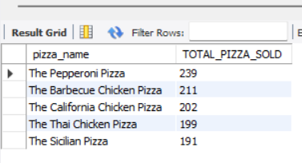

FOR THE MONTH OF JANUARY

**H. BOTTOM 5 WORST SELLERS BY TOTAL PIZZA_SOLD**

SELECT pizza_name, SUM(quantity) AS TOTAL_PIZZA_SOLD

FROM pizza_sales

WHERE MONTH(STR_TO_DATE(order_date,'%d-%m-%y'))=1

GROUP BY pizza_name

ORDER BY TOTAL_PIZZA_SOLD ASC

LIMIT 5;

